**SQL GUIDE NOTES**

https://www.youtube.com/watch?v=WXk7yDqsKxs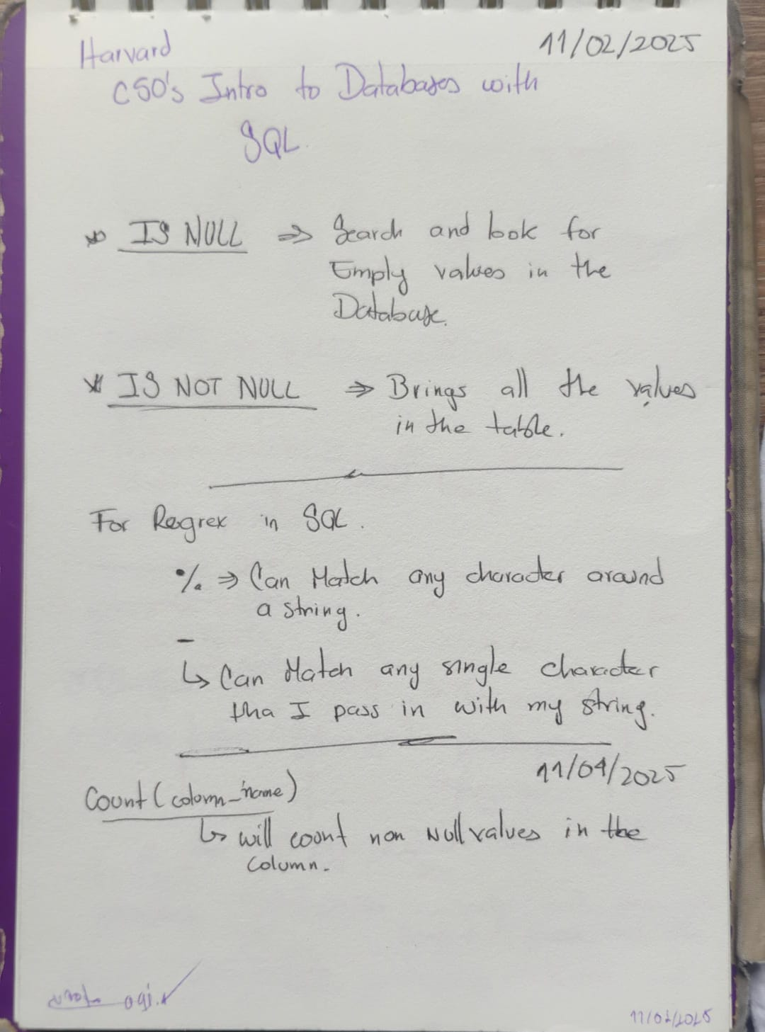

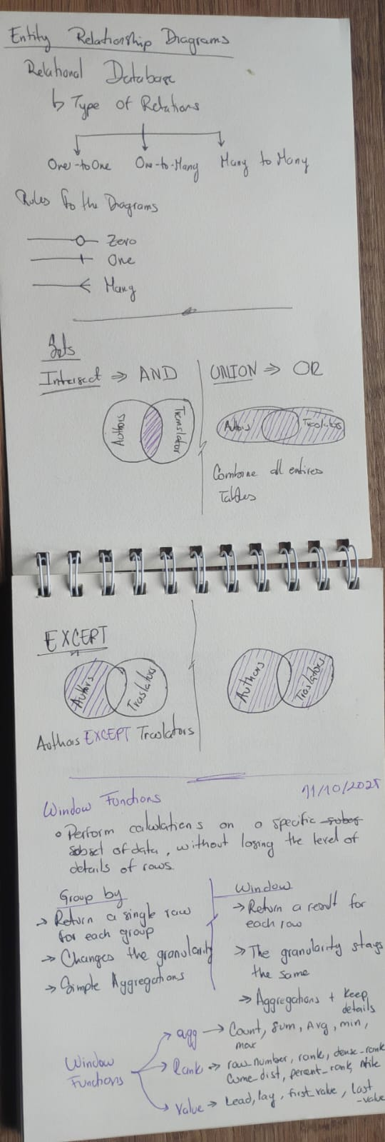

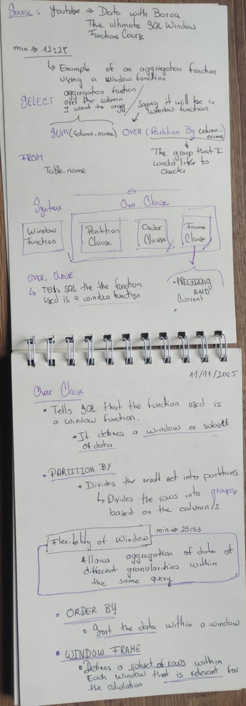https://www.youtube.com/watch?v=Wvg4PjbMTO8

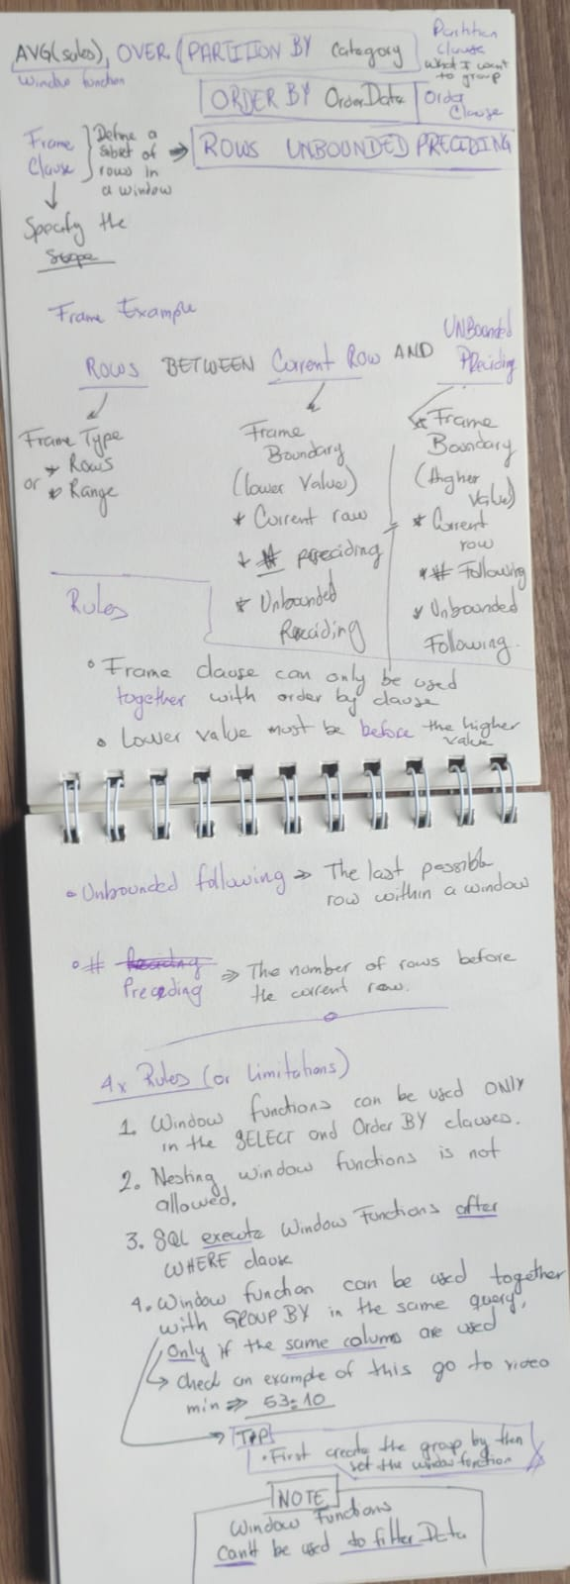

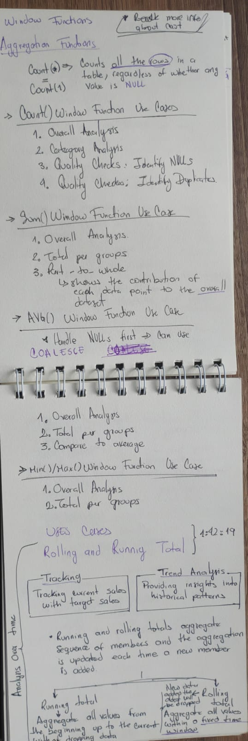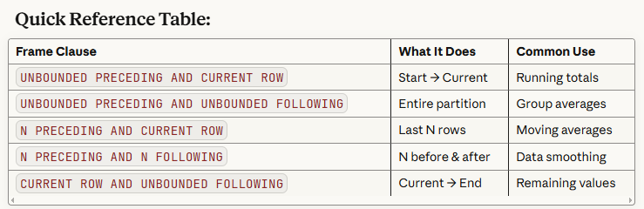

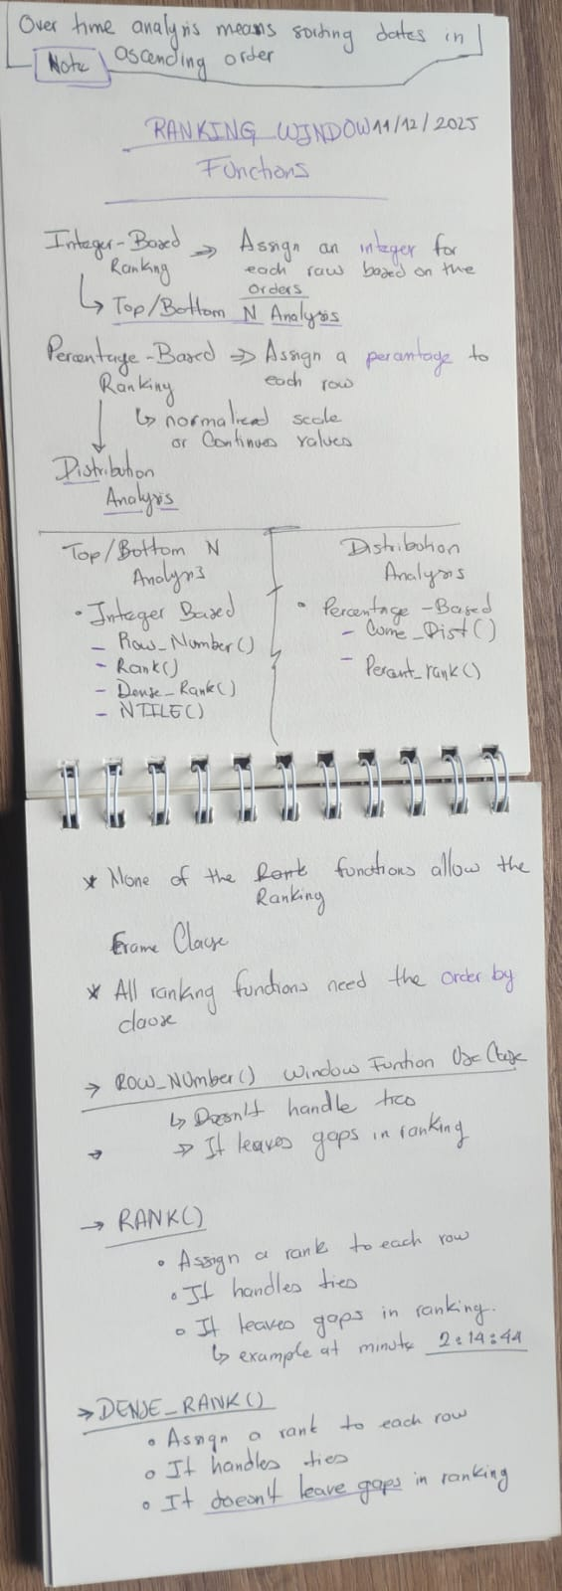

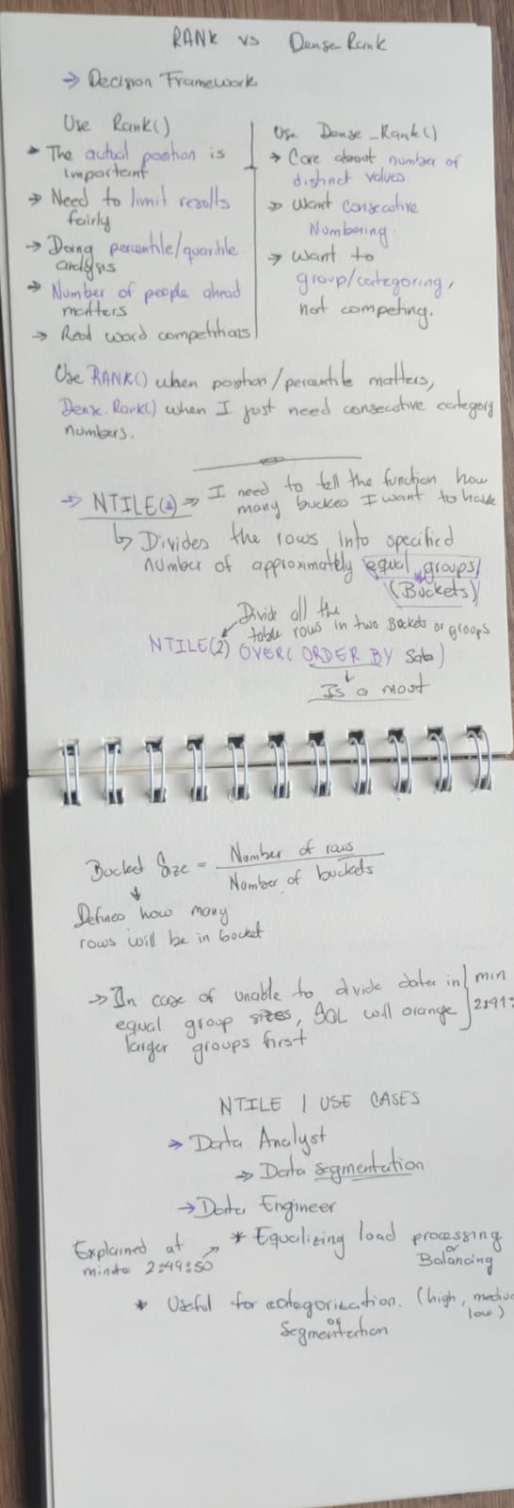

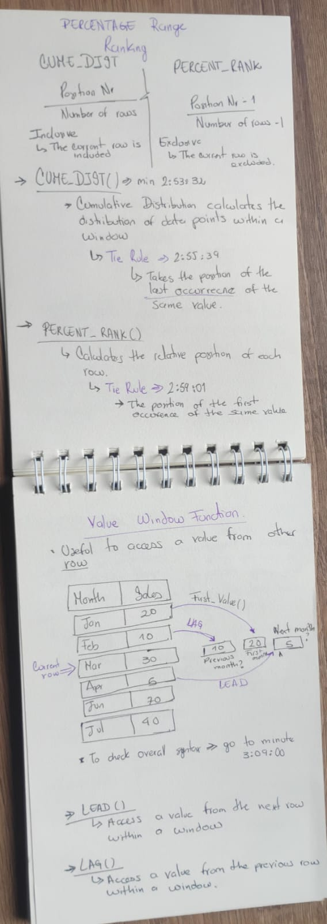

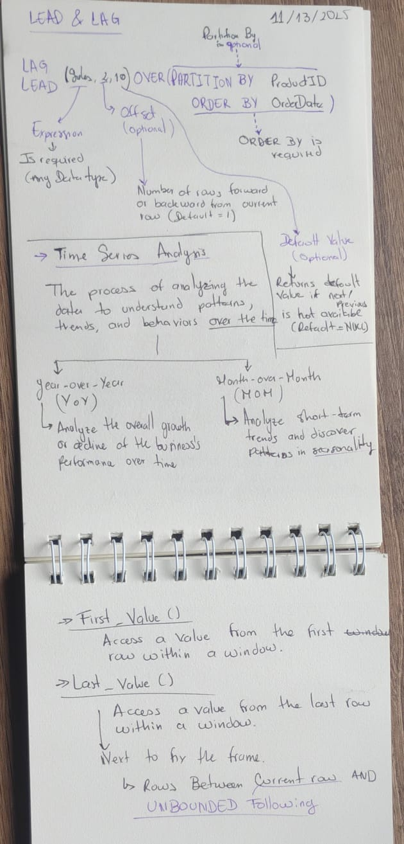

Regula Expressions

Source: <https://www.youtube.com/watch?v=nRRqgoqpxPg>